**Appendix C: Measured Surface UA Values, Measured Combined Surface Heat Transfer Coefficients, and Imputation of Selected Material Properties Based on Measured Data**

***[Note to Readers: Excel spreadsheets referenced within Appendix C are available upon request: contact Jeannie Kim (***[***jihyun.kim@anl.gov***](mailto:jihyun.kim@anl.gov)***) with cc to Joel Neymark (***[***neymarkj@msn.com***](mailto:neymarkj@msn.com)***)]***

### **C.1 Objectives**

* Determine UA values of each test-cell bounding surface based on empirical data (Section C.2)
* Determine constant combined surface heat transfer coefficients for each test cell bounding surface based on empirical data (Section C.4)
* Impute selected material conductivities (kimp) within each bounding surface based on measured UA values and measured surface heat transfer coefficients (Section C.3)
* Provide additional supporting information regarding appropriate simplification of original envelope construction drawings (Section C.5).

In the test specification, we applied imputed kimp instead of catalog-based material properties due to the disagreement between the measured overall building loss coefficients (BLC) and the calculated BLC from catalog material properties using 1-D heat-transfer equations. It was necessary to evaluate the UA of each surface to isolate the source of the overall BLC disagreement and adjust the UA for each surface accordingly.

UA values for each bounding surface are needed to quantify all heat flows to the guard zones. This is because it is necessary to maintain the guards at 10°C to ensure heating is always needed in the natural climate cases (no cooling system was provided inside the test cell), and because there is some variation among the guard zone temperatures.

Measured BLC includes infiltration, thermal bridging, multidimensional conduction effects, etc.

Drawings are simplified from original construction drawings so that:

* Input instructions are clear to users (less chance for input errors),
* BEM software inputs match the scheme for establishing kimp values (this is important for the steady-state cases and is also important for subsequent dynamic artificial and natural climate cases where empirically determined properties from these cases are applied).

### **C.2 Measured Surface UA Values**

The following tests were conducted to evaluate specific UA values.

Table 1 ETNA Test Cases for Surface UA Determination

|  |  |  |
| --- | --- | --- |
| **Case** | **Description** | **UA isolated** |
| ET100 | BLC uninsulated window | Overall BLC |
| ET110 | BLC insulated window | Overall BLC |
| ET131 | South wall (uninsulated window) | South wall |
| ET132 | South + Floor | Floor |
| ET134 | South + Floor + East (A) / West (B) | East (A) / West (B) wall |
| ET136 | South + Floor + East (A) / West (B) + Ceiling | Ceiling |
| ET137 | South + Floor + Ceiling + North | North wall |
| ET138 | South + Floor + Ceiling + North + West (A) / East (B) | West (A) / East (B) wall |
| ET140A | Cross Check: Cell A only | Overall BLC (A) and UA south (A), cross check |
| ET150B | BLC f (mixing): Cell B only | Overall BLC (B), f(mixing) |
| ET154B | BLC f (Tcell): Cell B only | Overall BLC (B), f(Tcell – Tguards,avg) |

1. Except for ET140A, 150B, and 154B, all the tests were done in both Cell A and Cell B.
2. Applying the measured UA values throughout the test suite further assumes that underlying test cell thermal properties do not vary substantially with conditions of either the test cells or the guard-zone, except as specified for some test cases.

The following steps were used to determine individual surface UA values:

1. Determine the building loss coefficient (BLC) of ET100 and ET110.
2. Determine the effect of window insulation on UA based on BLC difference of ET100 and ET110.
3. Determine the south wall UA based on ET131.
4. Determine the individual UA of other surfaces based on ET132 through ET138.
5. Steps 3 and 4 require iteration loops to refine UA values, based on possible adjustments to ΣQother (see C.2.3) for measured values rather than values calculated from material catalog properties.
6. Compare summed individual UA values to overall UA in ET100.
7. Possibly adjust UA values of other surfaces based on overall UA measurement; some engineering judgement is necessary to account for relative differences in the amount of multi-dimensional conduction present that could cause the sum of measured individual surface UA values to disagree with the measured overall BLC.
8. Use ET140 results in Cell A to compare measured heater and fan energy use to that calculated from the individual cell-guards temperature differences using the measured surface UA values. (This gives us a realistic estimate of the uncertainty in the surface UA values as we apply them in other cases.)

Note that for Cell A and Cell B tracer gas tests indicate that equivalent UA of infiltration (UAinf) is about 3% and 1% respectively of the overall BLC. We will assume that UAinf is picked up in each surface’s measured UA. This incorporates a further assumption that UAinf does not vary with conditions of either the cell or the guards.

Measured surface UA values are summarized below in Table C-1 for Cell A, and Table C-2 for Cell B. In Cell A and Cell B, the sum of the individually measured surface UA values (ET131-ET138) is 2.2% and 1.9% greater respectively than the measured overall BLC (ET100).

Detailed spreadsheet results are shown in Table C-3 for Cell A and Table C-4 for Cell B. These tables include average heater and fan powers along with test cell and individual guard zone temperatures during the steady-state period for each test case. In this table, the “ET110 Measured” UA values shown for each wall are adjusted (reduced by ratio of measured BLC to sum of individual wall UA values) so that they sum to the measured BLCs, respectively, for ET110A and ET110B.

Case ET140 (see Table C-3) suggests that the values given in Tables C-1 and Table C-2 can be used interchangeably with a resulting 7% uncertainty in estimated surface conduction. Some of this difference may be attributable to differences between Tcell – Tguards (15.5°C for ET140A versus 25°C for ET110A), and Tcell – Tsouth (31°C for ET140A versus 25°C for ET110A), as noted in the following paragraph. However, further analysis is needed regarding f(∆T, T) effects on UA as the test suite is further developed.

UA increases somewhat (-0.03 to 0.23 [W/°C]/[°C of ΔT]) with increasing cell-guard temperature difference. This is evident from the results of ET154B versus ET100B (only done in Cell B). This could be caused by (e.g.) increasing convective surface coefficients on the windows and increased natural convection within air gaps as cell-guard temperature difference increases.

Further details of the UA determinations are included in C.2.1 through C.2.4.

C.2.1 Determination of BLC in ET100 and ET110:

${BLC}_{overall}=Q_{cell}/(T_{cell}-T_{guards})$

where,

BLCoverall = empirically determined building loss coefficient (W/°C)

Qcell = sum of all measured Q generated in test cell (heater and fan)

Tcell = air temperature of test cell measured by the bulk temperature array

Tguards = mean temperature of the guard zones. Initial weighting of guard zone temperatures for determining average ΔT is based on UA-values from catalog-only listed thermal properties. Second iteration uses measured UA-values.

The difference between ET100 and ET110 is the effect of insulating the window.

C.2.2 Determination of Initial UA- and U-values for each bounding surface:

UA of each bounding surface, (UA)n, is determined by:

${(UA)}_{n}={BLC}_{overall}×(U_{calc,n}A_{n}/Σ(U_{calc,n}A_{n}))$

where,

Ucalc,n = calculated U-value with catalog material properties for a given (n) test-cell bounding surface, assuming 1-D conduction

An = interior surface area of given test-cell bounding surface

This determination is done for all surfaces and sub-surfaces (e.g., insulated windows).

The U-value, based on empirically determined UAtot (BLCoverall), for a given surface (Un) is then from:

$$U_{n}={(UA)}_{n}/A_{n}$$

This process is applied separately for each test cell.

C.2.3 The First Iteration of UA Determination for ET131 through ET138:

*C.2.3.1* *Determination of UA for the South Wall (ET131):*

First Iteration

$${UA}_{south,ET131}=Q_{south}/(T_{cell}-T_{south})$$

$Q_{south}=Q_{cell}-ΣQ_{other}$

$ΣQ_{other}=({BLC}_{adj,ET131}-{UA}_{calc,south})×(T_{cell}-T_{other})$

${BLC}_{adj,ET131}=({BLC}_{overall,ET100}+{BLC}_{overall,ET110})/2$

where,

Qcell = sum of all Q in cell (heater and fan)

$Σ$ Qother = heat flow to or from the other guard zones except for south guard zone

Tcell = air temperature of test cell

Tsouth = air temperature of south guard zone

Tother = weighted-average temperature of the guard zones except for south based on individual guard-zone temperature measurements, initial weighting of guard zone temperatures for determining Tguards applies bounding-surface UA-weighted averaging as described in C.2.2

UAcalc,south = calculated U-value with catalog material properties for south wall, assuming 1-D conduction

BLCoverall, ET100 = empirically determined building loss coefficient from ET100, where no insulation installed on both East and South windows (W/°C)

BLCoverall, ET110 = empirically determined building loss coefficient from ET110, where insulation installed on both East and South windows (W/°C)

BLCadj, ET131 = adjusted building loss coefficient for ET131 using BLCoverall of ET100 and ET110, where insulation installed only on East window (W/°C)

Interim

Same steps of the first iteration were repeated, but with the following:

UAcalc,south = UAsouth,ET131

Disaggregation of South wall (lumped) into UA of wall and window is presented in C.4.1.1 with interior surface heat transfer determination.

*C.2.3.2* *Determination of UA for Floor (ET132):*

First Iteration

$${UA}_{floor,ET132}=Q_{floor}/(T_{cell}-T_{cellar})$$

$Q_{floor}=Q_{cell}-Q_{south}-ΣQ_{{other}^{*}}$

$ΣQ_{{other}^{*}}=({BLC}_{adj,ET131}-{UA}_{south,ET131}-{UA}_{calc,floor})×(T_{cell}-T_{{other}^{*}})$

where,

Qcell = sum of all Q in cell (heater and fan)

Qsouth = , where UAsouth is as determined in ET131 (C.2.3.1)

$Σ$ Qother* = heat flow to or from the other guard zones except for south and cellar guard zones

Tcell = air temperature of test cell

Tcellar = air temperature of cellar guard zone

Tother* = weighted-average temperature of the guard zones except for south and cellar based on individual guard-zone temperature measurements, initial weighting of guard zone temperatures for determining Tguards applies bounding-surface UA-weighted averaging as described in C.2.2

UAcalc,floor = calculated U-value with catalog material properties for floor, assuming 1-D conduction

Interim

Same steps of the first iteration were repeated, but with the following:

UAcalc,floor = UAfloor,ET132

*C.2.3.3* *Determination of UA for East(A)/West(B) Wall and Ceiling (ET134 and ET136):*

The UA determination technique described below for east(A)/west(B) wall using ET134 was repeated for the measured UA of ceiling using ET136.

First Iteration

$${UA}_{east,ET134}=Q_{east}/(T_{cell}-T_{east})$$

$Q_{east}=Q_{cell}-Q_{south}- Q_{floor}-ΣQ_{{other}^{**}}$

$$ΣQ_{{other}^{**}}=\left({BLC}_{overall,ET100}-{UA}_{south,ET131}-{UA}_{floor,ET132}-{UA}_{calc,east}\right)$$

$$×(T_{cell}-T_{{other}^{**}})$$

where,

Qcell = sum of all Q in cell (heater and fan)

Qsouth = , where UAsouth is as determined in ET131 (C.2.3.1)

Qfloor = , where UAfloor is as determined in ET132 (C.2.3.2)

$Σ$ Qother** = heat flow to or from the other guard zones except for south, cellar, and east guard zones. As it goes to the next test case (ET136), an attic guard zone was excluded in addition to other guard zones kept out previously.

Tcell = air temperature of test cell

Teast = air temperature of east guard zone

Tother** = weighted-average temperature of the guard zones except for south and cellar based on individual guard-zone temperature measurements, initial weighting of guard zone temperatures for determining Tguards applies bounding-surface UA-weighted averaging as described in C.2.2. As it goes to the next test case (ET136), an attic guard zone was excluded in addition to other guard zones kept out previously.

BLCoverall, ET100 = empirically determined building loss coefficient from ET100, where no insulation installed on both East and South windows as in ET134 (W/°C)

UAcalc,east = calculated U-value with catalog material properties for east wall, assuming 1-D conduction

Interim

Same steps of the first iteration were repeated, but with the following:

UAcalc,east = UAeast,ET134

*C.2.3.4 Determination of UA for North and West(A)/East(B) Walls (ET137 and ET138):*

The UA determination technique described below for north wall using ET137 was repeated for the measured UA of west(A)/east(B) wall using ET138.

First Iteration

$${UA}_{north,ET137}=Q_{north}/(T_{cell}-T_{north})$$

$Q_{north}=Q_{cell}-Q_{south}- Q_{floor}-Q_{ceiling}-ΣQ_{{other}^{***}}$

$$ΣQ_{{other}^{***}}=\left({BLC}_{adj,ET131}-{UA}_{south,ET131}-{UA}_{floor,ET132}-{UA}_{ceiling,ET136}-{UA}_{calc,north}\right)$$

$$×(T_{cell}-T_{{other}^{***}})$$

where,

Qcell = sum of all Q in cell (heater and fan)

Qsouth = , where UAsouth is as determined in ET131 (C.2.3.1)

Qfloor = , where UAfloor is as determined in ET132 (C.2.3.2)

Qceiling = , where UAfloor is as determined in ET136 (C.2.3.3)

$Σ$ Qother*** = heat flow to or from the other guard zones except for south, cellar, attic, and north guard zones, as it goes to the next test case (ET138), exclude a west guard zone instead of north in addition to other guard zones kept out previously

Tcell = air temperature of test cell

Teast = air temperature of east guard zone

Tother*** = weighted-average temperature of the guard zones except for south and cellar based on individual guard-zone temperature measurements, initial weighting of guard zone temperatures for determining Tguards applies bounding-surface UA-weighted averaging as described in C.2.2. As it goes to the next test case (ET138), a west(A)/east(B) guard zone was excluded instead of north in addition to other guard zones kept out previously.

BLCadj, ET131 = adjusted building loss coefficient for ET131 using BLCoverall of ET100 and ET110, where insulation installed only on East window (W/°C)

UAcalc,north = calculated U-value with catalog material properties for east wall, assuming 1-D conduction

Interim

Same steps of the first iteration were repeated, but with following:

UAcalc,north = UAnorth,ET137

C.2.4 The Final Iteration of UA Determination for All Surfaces (ET100 through ET138):

Once the UA of all surfaces were determined using C.2.1 through C.2.3, the process was repeated finally with the following:

Tguards in C.2.1

$T_{guards}=Σ(T_{n}×U_{test case,n}A_{n})/Σ(U_{test case,n}A_{n}))$

where,

Tn = measured air temperature of each guard zone

Utest case,n = measured U-value of each surface for a given (n) test-cell bounding surface, using C.2.3 calculations

An = interior surface area of given test-cell bounding surface

UAcalc,n in C.2.2

UAcalc,n = UAtest case,n

where,

Utest case,n = measured U-value of each surface for a given (n) test-cell bounding surface, using C.2.3 calculations

BLC in C.2.3

${BLC}_{adj,ET131}=({BLC}_{{overall,ET100}^{*}}+{BLC}_{{overall,ET110}^{*}})/2$

where,

BLCoverll,ET100* = updated building loss coefficient for ET100 using updated Tguards above (W/°C)

BLCoverall,ET110* = updated building loss coefficient for ET110 using updated Tguards above (W/°C)

### **C.3 Imputation of Selected Thermal Conductivities**

Simulations inputs using measured UA values are developed by adjusting the conductivity of selected material layers. When possible, adjustments are made to insulation material conductivities where such layers are located on the exterior side of interior thermal mass. In this way the thermal mass behavior of the simulated versions of the test cells may be less affected by the UA adjustment.

An iterative solution method was applied to impute selected thermal conductivities (kimp) by implementing the Microsoft ExcelTM “GRG (Generalized Reduced Gradient) Nonlinear Solver” to minimize the difference between measured UA (See Section C.2) and UA calculated from catalog and selected imputed conductivities assuming steady-state 1-D conduction applying conduction paths defined in the test specification (see Section 2.2.1.7.2). Measured constant combined interior and exterior surface heat transfer coefficients (see Section C.4) are also applied for the calculated UA and resulting kimp values. In this process, the solver iterates until the difference between measured and calculated UA are within a reasonable tolerance, e.g., difference in UA value of 0.000001W/K.

Imputations of selected conductivities for each bounding surface are executed with “Imputation_of_k.xlsm”. Results are provided in Table C-5 for Cell A and Table C-6 for Cell B. In the xlsm workbook (also see Tables C-5 and C-6), the following apply:

* Material layers are listed from top to bottom, starting from the interior surface layer that is facing the test cell.
* “L” represents the layer thickness, “k,cat” represents the catalog conductivity of a given layer, “k,imp” represents the imputed conductivity of a given layer, and “μ” shows the ratio k,imp/k,cat.
* Font color (bold) applied to imputed values is as follows:
  + Orange: selected layers within opaque walls
  + Magenta: Path-3 layers when window insulation is applied
  + Purple: Path-1 and Path-2 layers when window insulation is applied.

To maintain consistent k,imp values among Cases ET100 and ET110 with window insulation not applied and applied, respectively, the East (Cell A), West (Cell B), and South (Cells A and B) walls have separate imputation steps that are documented in the xlsm file beginning in Row 208.

### **C.4 Determination of Constant Combined Surface Heat Transfer Coefficients**

C.4.1 Determination of Surface Heat Transfer Coefficients from Measured Data

The constant combined surface heat transfer coefficient for each test cell bounding surface was determined based on the best steady-state empirical data of ET131B, ET137B, and ET138B where the surface temperature (Tsurf) data were collected.

$$h_{int}=\frac{Q_{surf,n}}{A_{surf,n}∙(T_{cell}-T_{surf,n,int})}$$

$$h_{ext}=\frac{Q_{surf,n}}{A_{surf,n}∙(T_{cell}-T_{surf,n,ext})}$$

where,

hint = interior constant combined surface heat transfer coefficient

hext = exterior constant combined surface heat transfer coefficient

Qsurf,n = heat flow through the surface n

Asurf,n = area of surface n

Tcell = air temperature of test cell

Tsurf,n,int = interior surface temperature of surface n

Tsurf,n,ext = exterior surface temperature of surface n

The empirical determination of hint and hext was executed with “Determination_SurfHT-Periode4.xlsx” and as-measured values shown in Table 2.

Table 2 As-measured hint and hext for all surfaces before adjustment a



a. Table 2 is from “Determination_SurfHT-Periode4….xlsx”, Refinement_f(T,delT,V)!CH51:CN66.

*C.4.1.1 Determination of South Wall and Window Interior Combined Surface Heat Transfer Coefficients*

**Objective and Method:** Due to greater temperature difference between Tcell and Tsurf,south,window,int (average 7.23˚C) than Tsurf,south,wall,int (average 1.59˚C) where the south window is uninsulated (as in Case ET131B), we determined hint for south wall and window separately. This determination is based on individual inside surface temperature measurements for the south wall and window applying an iterative process as follows.

Initialization: Determination of hint for Lumped South Wall (Wall and Window)

In the first iteration, hint for the entire south wall including an insulated window area is calculated based on the formula in Section C4.1 above (executed in “Determination_SurfHT-Periode4.xlsx”, Tab “SouthB_Initialization”) and then refined for ET110A as shown in C.4.2.1 (executed in “Determination_SurfHT-Periode4.xlsx”, Tab “Refinement_f(T,delT,V).”)

$$h_{int,avg,south,Measured}=\frac{Q_{surf,south}}{A_{surf,south}∙(T_{cell}-T_{surf,south,int})}$$

$$h_{int,avg,south,ET110A}=\frac{h_{int,south,f(T,∆T,V),ET110A}}{h_{int,south,f(T,∆T,V),Measurement}}×h_{int,avg,south,Measured}$$

This adjusted hint is then entered in “Imputation_of_k.xlsm” to impute conductivity values in south wall and window (see Tab “ET110B k,imp (Initial).”)

Interim

Using UA of south wall and window with imputed conductivity in “Imputation_of_k.xlsm”, Tab “ET110B k,imp (Initial)”, Qsurf,south is divided proportionally and hint is separately determined for wall and window surfaces (executed in “Determine_SurfHT-Periode4.xlsx”, Tab “SouthB_Win_Wall”, where UA inputs are to cells AN2, AO2 with results for hint,win and hint,wall shown in cells BD1714 and AV1714, respectively). The hint,win and hint,wall results are then refined for ET110A as shown in C.4.2.1 (executed in “Determine_SurfHT-Periode4.xlsx”, Tab “Refinement_f(T,delT,V).”)

$$h_{int,avg,south,wall,Measured}=\frac{Q_{surf,south,wall}}{A_{surf,south,wall}∙(T_{cell}-T_{surf,south,wall,int})}$$

$$h_{int,avg,south,window,Measured}=\frac{Q_{surf,south,window}}{A_{surf,south,window}∙(T_{cell}-T_{surf,south,window,int})}$$

$$h_{int,avg,south,wall,ET110A}=\frac{h_{int,south,wall,f(T,∆T,V),ET110A}}{h_{int,south,wall,f(T,∆T,V),Measurement}}×h_{int,avg,south,wall,Measured}$$

$$h_{int,avg,south,window,ET110A}=\frac{h_{int,south,window,f(T,∆T,V),ET110A}}{h_{int,south,window,f(T,∆T,V),Measurement}}×h_{int,avg,south,window,Measured}$$

These adjusted hint,south,wall and hint,south,window are entered in “Imputation_of_k.xlsm” to re-impute conductivity values in south wall and window (Tab “ET110B k,imp.”) The interim step is iterated until the adjusted hint for both south wall and window reach convergence. Table 3 shows hint and UA of south wall and window in each iteration.

Table 3 Iterations to determine hint,south,wall and hint,south,window



C.4.2 Adjustment of Coefficients to Account for Test Cell and Guard Zone Temperature Differences For Case ET110 Versus Measured Surface Heat Transfer Data from Other Cases

For determining imputed conductivities, hint and hext for Case ET110 are provided by adjusting measured h for a given surface to account for differences in the temperature difference between the test cell and each guard zone for Case ET110 versus the cases where hint and hext are measured. If a user can justify applying different surface coefficients (based on surface heat transfer physics), or is otherwise applying other values, then given kimp values (see Section C.3) may not apply and the user may revise such kimp values accordingly.

*C.4.2.1 Interior Surface Heat Transfer Coefficient (hint) Refinement*

**Objective and Method:** Provide hint for Case ET110A by adjusting measured hint for a given case, where the adjustment accounts for differences in Tcell radiant effect, ∆T (i.e., Tcell – Tsurf,int), and interior bulk air velocity between Case ET110A and the case where hint is measured for a given surface. We chose to use the EnergyPlus DOE-2 (“DOE2”) surface convection algorithm combined with a linearized radiative coefficient for calculating an adjustment ratio applying hint determined for Case ET110A versus hint for the case where hint for a given surface is measured and then applying that ratio to the measured hint for a given surface. The “DOE2” algorithm is a blend of the TARP (Walton 1983) and MoWiTT (Yazdanian and Klems 1994) algorithms as described in the EnergyPlus Engineering Reference (2022). Here the “DOE2” algorithm is applied to inside surfaces rather than outside surfaces.

The resulting f(Tcell, ∆T) refinements specific to Cases ET110A and ET110B are provided in Table 4. The method details for developing Table 4 are provided in the following paragraphs. Table 4 indicates greater effect (as % of total combined coefficient) attributable to the radiative coefficient (hrad) for greater Tcell of ET110 versus the cases where surface heat transfer is measured (ET131B, ET137B, and ET138B).

For the south wall in particular, the greater radiative coefficient increase for Tcell in ET110 (versus ET131B) outweighs the effect on convection of the greater cell-to-guard zone ∆T of Case ET131. Overall, after balancing h,int,south,wall and h,int,south,window with UAsouth,wall and UAsouth,window per Section C.4.1.1, the effect of f(Tcell, ∆T, V) refinement on the interior surface heat transfer coefficients for all surfaces is within their measurement uncertainty.

Table 4 Adjustment ratios using h,int,n,f(T,delT,V) algorithm and the final hint a





a. Table 4 is from “Determine_SurfHT-Periode4.xlsx”, Refinement_f(T,delT,V)!AY51:CF67.

Determine hint of ET110A using measured hint as follows.

The initial relationship of interest is:

$$\frac{h_{int,avg,n,ET110A}}{h_{int,avg,n,Measured}}=\frac{h_{int,n,f(T,∆T,V),ET110A}}{h_{int,n,f(T,∆T,V),Measurement}}$$

which implies

$h_{int,avg,n,ET110A}=h_{int,avg,n,Measured}×\frac{h_{int,n,f(T,∆T,V),ET110A}}{h_{int,n,f(T,∆T,V),Measurment}}$ where,

$h_{int,avg,n,ET110A}$ is averaged hint for the interior surface *n* in Case ET110A (measured overall BLC with insulated windows).

$h_{int,avg,n,Measured}$ is averaged hint for the interior surface *n* in the case where hint of a given surface *n* is from measurements (see SurfHT-Periode4-mmddyytk.xlsx).

$h_{int,n,f(T,∆T,V),ET110A}$ is hint calculated via the “DOE2” algorithm for each interior surface *n* at ∆Tn,ET110A and VET110A. The form of the “DOE2” algorithm is presented in Item “3)”.

$h_{int,n,f(T,∆T,V),Measurement}$ is hint calculated via the “DOE2” algorithm for each interior surface *n* at ∆Tn,Measured and Vn,Measured.

represents the combined interior surface heat transfer coefficient that includes both the convection coefficient ($h_{c}$) and the radiative coefficient ($h_{rad}$).

1. $h_{int,n,f(T,∆T,V),ET110A}$: hint via “DOE2” calculation and radiant effect as f(Tcell) in Item “4)” for ET110A

where the following are developed for applying to the “DOE2” algorithm (see Item “3)”):

${∆T}_{n,ET110A}=(T_{cell,n,Measured}-T_{surf,int,avg,n,Measured})×\frac{{(T_{cell}-T_{grd})}_{n,ET110A}}{{(T_{cell}-T_{grd})}_{n,Measured}}$

where,

${∆T}_{n,ET110A}$ is the difference between the test cell bulk average temperature and the temperature of surface *n* in ET110A.

$T_{cell,avg,n,Measured}$ is the test cell bulk average temperature in the case where hint of a given surface *n* is measured.

$T_{surf,int,avg,n,Measured}$ is the average temperature of surface *n* in the case where hint of a given surface *n* is measured.

${(T_{cell}-T_{grd})}_{n,ET110A}$ is the best-steady-state air temperature difference between the test cell and the guard zone for given surface *n* in ET110A.

${(T_{cell}-T_{grd})}_{n,Measured}$ is the best-steady-state air temperature difference between the test cell and the guard zone for given surface *n* in the case where hint of a given surface *n* is measured.

$$V_{avg,ET110A}=\frac{{\dot{V}}_{avg,ET110A}}{({V_{{cell}_{A}}}^{2/3}* 3600) }$$

where,

$V_{avg,ET110A}$ is the average interior air velocity (m/s), which is applied to all interior surfaces as well.

${\dot{V}}_{avg,ET110A}$ is the average volumetric flow rate from the heater with diffusers during the best steady state period in ET110A (m3/h).

is the volume of Cell A (m3).

1. : via “DOE2” calculation and radiant effect as f(Tcell) for measurement

$${∆T}_{Measurement,n}=(T_{cell,avg,n,Measured}-T_{surf,int,avg,n,Measured})$$

where,

${∆T}_{Measurement,n}$ is the difference between the test cell bulk average air temperature and the temperature of surface *n* in the case where hint of a given surface *n* is measured.

$T_{cell,avg,n,Measured}$ is the test cell bulk average air temperature in the case where hint of a given surface *n* is measured.

$T_{surf,int,avg,n,Measured}$ is the average temperature of surface *n* in the case where hint of a given surface *n* is measured.

$$V_{n,Measured}=\frac{{\dot{V}}_{avg,n,Measured}}{({V_{{cell}_{A}}}^{2/3 }* 3600)}$$

where,

$V_{n,Measured}$ is the average interior surface air velocity (m/s) for a given surface in the measurement case.

${\dot{V}}_{avg,n,Measured}$ is the average volumetric flow rate (m3/h) from the heater with diffusers during the best steady state period in the case where hint of a given surface *n* is measured.

$V_{{cell}_{A}}$ is the volume of Cell A (m3).

1. DOE-2 (EnergyPlus Engineering Reference, 2022)

The DOE-2 convection model is a combination of the MoWiTT and BLAST Detailed convection models.

* STEP 1: calculation of hn

The natural convection component hn is calculated in the same way as the interior “Detailed” model. The detailed natural convection model correlates the convective heat transfer coefficient to the surface orientation and the difference between the surface and zone air temperatures (where ΔT = Air Temperature - Surface Temperature).

For a vertical surface (all walls in ET110A), the following correlation is used:

$$h_{n}=1.31{\left|∆T\right|}^{\frac{1}{3}}$$

For $∆T>0.0$ and a downward facing surface (the ceiling in ET110A), the following correlation is used:

$$h_{n}=\frac{9.482{\left|∆T\right|}^{\frac{1}{3}}}{7.238-\left|cos Σ\right|}$$

Where Σ is the surface tilt angle. Then for the ET110A ceiling:

$$h_{n}=1.52{\left|∆T\right|}^{\frac{1}{3}}$$

For $∆T>0.0$ and an upward facing surface (the floor in ET110A), the following correlation is used:

$$h_{n}=\frac{1.810{\left|∆T\right|}^{\frac{1}{3}}}{1.382+\left|cos Σ\right|}$$

Where Σ is the surface tilt angle. Then for the ET110A floor:

$$h_{n}=0.76{\left|∆T\right|}^{\frac{1}{3}}$$

* STEP 2: calculation of hc,glass

The convection coefficient for very smooth surfaces (e.g., glass) is calculated

as:

$$h_{c,glass}=\sqrt{{h_{n}}^{2}+{\left[a{V_{z}}^{b}\right]}^{2}}$$

where $V_{z}$ is air velocity, and:

|  |  |  |
| --- | --- | --- |
| **Wind Direction** | **a** | **b** |
| **Units** | **W/m2K(m/s)b** | **-** |
| Windward | 3.26 | 0.89 |
| Leeward | 3.55 | 0.617 |

For this analysis, $V_{z}$ is based on HWD supply air flow rate for a given test case, and the windward coefficients are applied.

* STEP 3: calculation of hc

For less smooth surfaces, the convection coefficient is modified according to the equation:

$$h_{c}=h_{n}+R_{f}(h_{c,glass}-h_{n})$$

where Rf is the roughness multiplier

|  |  |  |
| --- | --- | --- |
| **Roughness Index** | **Rf** | **Example Material** |
| 1 (Very Rough) | 2.17 | Stucco |
| 2 (Rough) | 1.67 | Brick |
| 3 (Medium Rough) | 1.52 | Concrete |
| 4 (Medium Smooth) | 1.13 | Clear pine |
| 5 (Smooth) | 1.11 | Smooth Plaster |
| 6 (Very Smooth) | 1.00 | Glass |

For this analysis, Rf = 1.11 is applied for the interior surfaces.

1. Calculation of hrad and hcomb

The radiative coefficient is calculated regarding the test cell temperature according to the equation:

$$h_{rad}=4eσ{T_{cell}}^{3}$$

where,

$e$ is emissivity of the surface. For this analysis, e = 0.9 is applied for the interior surfaces.

$σ$ is the Stefan-Boltzmann constant of 5.670374419 x 10-8 W/(m2K4).

is the cell temperature of ET110A in kelvin (the absolute temperature) during the best steady-state period.

The combined surface heat transfer coefficient is the sum of the convection and radiative coefficients as follows:

$$h_{comb}=h_{c}+h_{rad}$$

where,

$h_{c}$ is the convection coefficient of the surface using the step 1 through 3 above mentioned.

$h_{rad}$ is the radiative coefficient of the surface using the step 4 above mentioned.

The radiative coefficient formulation comes from ASHRAE Standard 140 (2020), informative Annex B5, adapted from Duffie and Beckman (1974).

C.4.2.2 Exterior Surface Heat Transfer Coefficient (hext) Refinement

**Objective and Method:** Directly compare the calculated $h_{ext}$ using the h = f(Tcell, ∆T, V) algorithm (as presented above) and the measured $h_{ext}$, assess measurement quality, and select appropriate values of combined exterior surface heat transfer coefficient for each surface as shown in Table 5.

Table 5 Comparison with the f(Tcell, ∆T, V) algorithm and the final hext



a. Table 5 is from “Determine_SurfHT-Periode4.xlsx”, Refinement_f(T,delT,V)!AF51:AW63.

Following discussion relates to selection of hext,final in above table.

$h_{ext,South,meas}$

* One of the best measurements with lower uncertainty Qsurf and greatest Tsurf,ext – Tguard, implying lower relative uncertainty of the hext measurements.
* South wall window is uninsulated in ET131B but insulated in ET110A; for ET110A we apply hext,south as determined from the ET131B measurements because the greater exterior coefficients (versus interior coefficients) indicate there is greater forced convection effect in the guard zones and south wall is 80% opaque wall construction.
$h_{ext,North,meas}$

* One of the best measurements, and having more uniform Tsurf,ext measurement and perhaps more forced-convection driven than south wall. (Although, hext,n ≃ hext,s calls into question the record of the guard-zone air velocity measurements.)
* For the south and north walls, hcomb,ext calculated using “DOE-2” algorithm apply listed air velocities for surface convection, along with linearized radiation exchange, is less than half of the measured values.

$h_{ext,East}$

$${h }_{ext,East}= h_{ext,North,meas} * (\frac{h_{ext,East,f(T,∆T,V)} }{h_{ext,North,f(T,∆T,V)}})$$

Resulting 20 W/(m2K) falls within uncertainty of 27.1 ± 11.4 W/(m2K), and was initially considered because east guard convective surface heat transfer appears as forced-convection dominated regime, and because of high u(hext,meas) caused by Tsurf,ext – Tguard < 0.2°C. However, based on discussion with Item “8)” below, we chose 18 W/(m2K) for all hext values, which is also within the hext,East measurement uncertainty.

$h_{ext,West}$

$$h_{ext,West} = (h_{ext,North,meas} + h_{ext,South,meas})/2$$

There was no direct measurement of west wall surface heat transfer, so hcomb,ext,w is based on north and south because:

* West wall has similar R-value as North and South Wall
* Air movement (V) may be similar as the South guard
* Guard temperature (Tguard) is similar as the South guard, i.e., overall exterior-surface-to-guard-zone ∆T,ET110A similar to ∆T,ET131B (south)
* 0.3 W/(m2K) difference of hrad vs south (4.64 vs 4.24 W/(m2K)) is well within measurement uncertainty.

$h_{ext,Floor}$

$$h_{ext,Floor} = (h_{ext,North,meas} + h_{ext,South,meas})/2$$

Tsurf,ext,floor measurement appears faulty (too low Tsurf,ext – Tcellar, and in opposite directions for ET137B and ET138B, i.e., Tsurf,ext too closely matches Tcellar), so we assume ETNA cellar guard is similar to south and north guards with respect to hext.

* According to the ETNA 2004 document (Neymark et al 2004, Section 2.2.1.6.2.2), unlike other guard zones the attic velocity sensors are not accessible and ceiling air measurements are estimated.
* Low hext flags possibly too high Tsurf,ext – Tattic for measured attic R-value. This calls into question the location of ceiling exterior surface heat transfer sensors (see likely related note above about accessibility of attic velocity sensors). So, it seems best to assume the ETNA attic guard is similar to south and north guards with respect to hext.

1. Velocity measurements

* As noted with Item “2)” the occurrence of measured hext,n ≃ hext,s coinciding with differences in average guard zone air velocity raises the question of the accuracy of guard zone velocity measurement record.
* According to the ETNA 2004 document (Section 2.2.1.6.2.2), only maximum, minimum and average velocities for all test periods are provided; we do not have hourly measurements of guard zone air velocities or guard zone supply air flow rates (as we have for the test cells).
* Therefore, for simplicity and because measured hext,n ≃ hext,s, we are assuming that the EdF data acquisition team strove to provide well mixed air in all guard zones with bulk air velocities roughly approximating conditions that may occur outdoors such that all hext may be assumed as roughly equal. (Neymark recalls feeling the draft of the airflow when entering some guard zones – e.g., south guard and Cell A east guard -- however, he does not recall entering all guard zones during data collection.)

1. Selection of hext = 18

* hext,n = 17.8 ± 5.8 W/(m2K) and hext,s = 17.8 ± 5.7 W/(m2K) leads us to:

hext ≃ 18 ± 6, as a rounded value and uncertainty for both exterior surfaces.

Given the uncertainties of these measurements, it is perhaps serendipitous that the measured values of hext,n and hext,s (around which their uncertainties occur) are within 0.1 W/(m2K).

* Per notes above, hext,n and hext,s are ETNA’s best measurements of exterior surface heat transfer, and we are applying these values to all exterior surfaces.
* Potential effects of these assumptions:
  + For the natural climate cases, Tguards ≃ Tcell except that the south wall is exposed to natural climate, so for all other guards hext, the interactive effect of hext and selected kimp of bounding surfaces on resulting Qcell should be negligible.
  + For the steady-state artificial climate cases, there may be some resulting inaccuracy of selected kimp but not to overall measured UA, so the overall effect on modeled versus measured Qcell should be negligible
  + For dynamic artificial climate cases, where Tcell is varied while Tguards remains relatively constant for each guard zone, characterization of interior surface heat transfer is more important than exterior surface heat transfer. Fortunately, we have better measurements for interior surface heat transfer than for exterior surface heat transfer, though some inaccuracy is introduced by lack of better exterior surface heat transfer measurements.

**C.5 Simplification of Envelope Construction**

Simplification of selected constructions balances the need to accurately convey the test cell to models while reducing the potential for input errors, i.e., to facilitate accurate modeling. Three types of simplifications were done:

* When the uniform thermal resistance (1-D) is changed by materials penetrating multiple layers in envelope construction, multiple individual 1-D conduction paths are defined. This was applied for the ceiling, floor, and window insulation as shown below.
* When materials within a layer are non-uniform (e.g., radiant heating tubes embedded in floor concrete layer, varying thickness of door materials, integrating window setback cavity facing [thermal bridge] with window frame), the equivalent conductivity, density, and specific heat of materials in simplified layers are calculated using volume-weighted averages of the original material properties. This was applied for the floor, door, and uninsulated and insulated windows.
* When the effect of a penetrating layer is deemed insufficient or too uncertain to justify conveying to a model, the material is not applied. Such a penetrating layer was eliminated for the ceiling.

A further justification for simplifying the material layer constructions to facilitate modeling is that selected material conductivities are imputed based on measured individual surface UA values, so that the as-built UA-value of the constructions are accurately conveyed to models (see Section 2.1.10 “Recommended Consumption Instructions of the Test Specification”). Such imputations implicitly account for as-built complexities such as thermal bridges, 2-3/D conduction, infiltration, etc. Where imputed conductivities are provided, it is still important to maintain the intended scheme of the original construction layers (rather than simply specify a lumped UA value) so that intended thermal mass characteristics are modeled for later dynamic (non-steady state) artificial and natural climate cases.

The original constructions and material properties of each envelope are presented here in detail with simplifications described for the ceiling, floor, door, and window insulation (relevant section of the test spec is included in parenthesis with subsection headers below).

C.5.1 Ceiling (2.2.1.7.2.6)

*C.5.1.1 Original Construction and Material Properties*

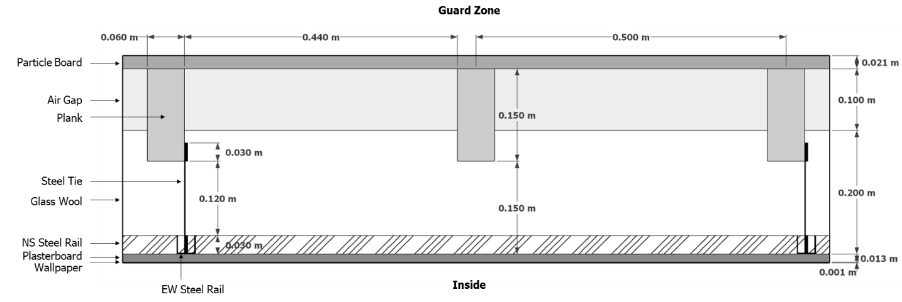

Figure 1 Sectional view of the ceiling (partial) – Original Construction (vertical section)

Informative Notes: Steel ties do not extend through entire section; they are 1 mm x 20 mm (depth into page), and 40 total ties for cross-section area = 0.0008 m2, and overlap on the wood plank above by 3 to 4 cm. The bottom of the ties is connected to u-channel rails affixed to the ceiling plasterboard. There are nine wooden plank beams above the ceiling (East-West) and NS and EW rails are placed perpendicularly; NS steel rails are placed along with eight steel ties per plank and EW rails and ties are applied every other beam.

Table 6 Characteristics of the ceiling – Original Construction

|  |  |  |  |  |
| --- | --- | --- | --- | --- |
| Material | d  Thickness  [m] | k  Conductivity  [W/mK] | ρ  Density  [kg/m3] | Cp  Specific heat  [J/kgK] |
| Wallpaper | 0.001 | 0.14 | 700 | 1340 |
| Plasterboard | 0.013 | 0.35 | 850 | 800 |
| Glass wool | 0.200 | 0.042 | 11 | 800 |
| Steel ties | 0.18 | 43 | 7870 | 460 |
| Steel rails | 0.03 | 43 | 7870 | 460 |
| Planks | 0.15 | 0.15 | 500 | 1200 |
| Air gap | 0.100 | 0.618 | 1.2 | 1000 |
| Particle board | 0.021 | 0.17 | 700 | 1200 |

*C.5.1.2 Simplified Construction and Equivalent Material Properties*

Due to the lack of information on the steel ties and rails – its specific dimensions, arrangement, and thermal properties were not clarified on the original test document – we neglect these parts completely as in Fig 12 (in 2.2.1.7.2.6) and by imputing the conductivity of glass wool, made any additional thermal conduction (e.g., thermal bridge) occurred by these parts be incorporated in the simple parallel paths. In addition, we conducted the 2/3-D analysis using THERM and confirmed that the neglected parts (steel ties and rails) account for only about 2% of thermal heat flux.

C.5.2 Floor (2.2.1.7.2.7)

The floor has a complicated construction relative to the other boundary surfaces, with its original drawings and thermal property tables providing a less clear description of its construction than original drawings and tables for other surfaces. This situation led us to prioritize, in the test cell characterization test sequence, measuring the UA values of the Cell A and Cell B floors just after measuring the Cell A and Cell B south wall UA values.

*C.5.2.1 Original Construction and Material Properties*

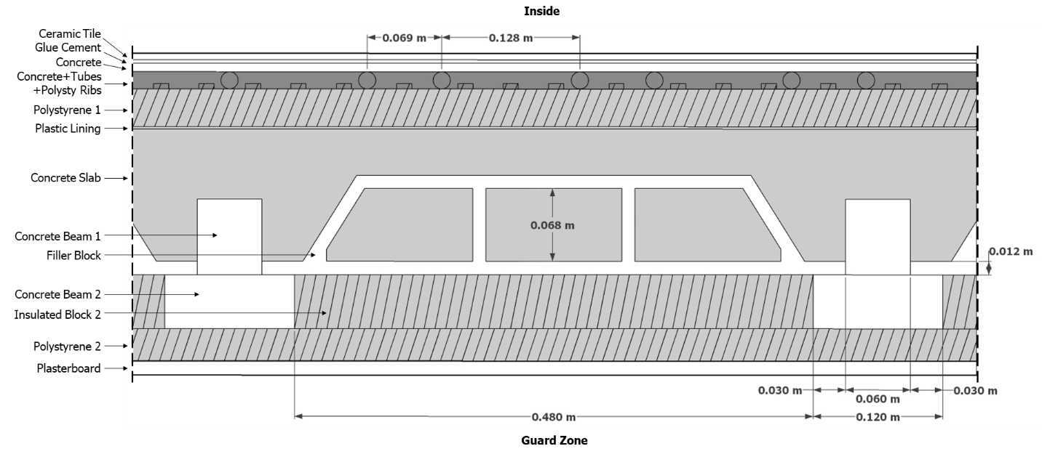

Figure 2 Section/elevation view of the floor – Original Construction (vertical section)

Table 7 Characteristics of the floor – Original Construction

|  |  |  |  |  |
| --- | --- | --- | --- | --- |
| Material | d  Thickness  [m] | k  Conductivity  [W/mK] | ρ  Density  [kg/m3] | Cp  Specific heat  [J/kgK] |
| Ceramic Tile | 0.006 | 1.75 | 2177 | 920 |
| Glue Cement | 0.003 | 1.50 | 1900 | 840 |
| Concrete | 0.008 | 1.75 | 2177 | 920 |
| Concrete + Tubes + Polysty Ribs | 0.016 | 1.47 | 1670 | 998 |
| Polystyrene 1 | 0.035 | 0.04 | 16 | 1200 |
| Plastic Lining | 0.002 | 0.124 | 265 | 1170 |
| Concrete Slab | 0.065 | 1.75 | 2200 | 950 |
| Concrete Beam 1 | 0.070 | 1.75 | 2200 | 950 |
| Concrete Beam 2 | 0.050 | 1.75 | 2200 | 950 |
| Filler Block | 0.092 | 0.1-0.7 a | 400-1700 a | 840 b |
| Insulated Block 2 | 0.050 | 0.04 | 18 | 1200 |
| Polystyrene 2 | 0.030 | 0.04 | 18 | 1200 |
| Plasterboard | 0.013 | 0.35 | 850 | 800 |

1. Li F, Chen G, Zhang Y, Hao Y, Si Z. Fundamental Properties and Thermal Transferability of Masonry Built by Autoclaved Aerated Concrete Self-Insulation Blocks. Materials (Basel). 2020 Apr 3;13(7):1680. doi: 10.3390/ma13071680. PMID: 32260236; PMCID: PMC7178685.
2. Designing Buildings, The Construction Wiki. Specific Heat Capacity. https://www.designingbuildings.co.uk/wiki/Specific_heat_capacity

*C.5.2.2 Simplified Construction and Equivalent Material Properties*

There was a radiant floor system installed that was not in use, therefore no water existed inside of the tubes. The properties of this blended layer “Concrete + Tubes + Polysty Ribs” were assumed using volume-weighted averages shown in the table below.

Table 8 Blended Layer Property: “Concrete + Tubes + Polysty Ribs”

|  |  |  |  |  |  |  |
| --- | --- | --- | --- | --- | --- | --- |
| **Floor Blended Layer** | Area  [m2] | Thickness  [m] | Volume  [m3] | Conductivity  [W/mK] | Density  [kg/m3] | Specific Heat  [J/kgK] |
| Concrete | 16.29 | 0.016 | 0.21585 a | 1.75 | 2177 | 920 |
| Tube | 128 a | 0.016 | 0.00875 a | 0.35 | 265 | 1170 |
| Air within empty tubes | 128 a | 0.013 | 0.01699 a | 0.08 | 1.2 | 1000 |
| Polystyrene Rib | 381.86 b | 0.005 | 0.01909 b | 0.04 | 16 | 1200 |
| **Blended** | **16.29** | **0.016** | **0.26068** | **1.47** | **1813** | **954** |

1. The total length of tubes is 128 m. Volume of air within tubes = π (0.013/2)2 x 128. Volume of tubes = π (0.016/2)2 x 128 – π (0.013/2)2 x 128. The volume of the concrete is the volume of the total floor blended layer less the volumes of the tubes, air within the tubes, and the polystyrene ribs.
2. The cross-section area of the slice of the rib is 0.00005 m2 (thickness 0.005 m, width 0.01m) and there are approximately 82 ribs along the North-South side of the floor (4.655 m length).

Because of it’s non-uniform geometry, it was also simpler to integrate the “Filler Block” material within the construction as “Insulated Block 1”, see Figure 13a (Section 2.2.1.7.2.7).

C.5.3 Door within North Wall (2.2.1.7.2.8)

*C.5.3.1 Original Construction and Material Properties*

Figure 3 Door Insulation – Original Construction (horizontal section)

Table 9 Characteristics of the door – Original Construction

|  |  |  |  |  |
| --- | --- | --- | --- | --- |
| Material | d  Thickness  [m] | k  Conductivity  [W/mK] | ρ  Density  [kg/m3] | Cp  Specific heat  [J/kgK] |
| Wood + Air + Cardboard | 0.044 | 0.09 | 250 | 1100 |
| Air Gap (Wood+Air+Cardboard) a | 0.030 | 0.20 | 1.2 | 1000 |
| Plywood | 0.020 | 0.109 | 590 | 2500 |
| Air Gap (Plywood) a | 0.054 | 0.36 | 1.2 | 1000 |
| Plexiglass | 0.005 | 0.195 | 1180 | 1000 |
| Air Gap (Plexiglass) a | 0.069 | 0.46 | 1.2 | 1000 |
| Door Styrodur | 0.060 | 0.032 | 18 | 1200 |

a. Material in parenthesis is adjacent to air gap in Figure 3

*C.5.3.2 Simplified Construction and Equivalent Material Properties*

To reduce the heat flux paths through the door, we’ve combined Wood + Air + Cardboard (using a catalog value for a hollow door), Plywood, and Plexiglass materials into one layer with thickness of 0.036 m and Air Gaps into the same thickness layer of 0.038 m using volume-weighted averages of each material as shown in tables below.

Table 10 Blended Layer Property: “Blended Wood/Air/Cardboard + Plywood + Plexiglass”

|  |  |  |  |  |  |  |
| --- | --- | --- | --- | --- | --- | --- |
| **Door Blended Layer** | Area  [m2] | Thickness  [m] | Volume  [m3] | Conductivity  [W/mK] | Density  [kg/m3] | Specific Heat  [J/kgK] |
| Wood + Air + Cardboard | 1.254 | 0.044 | 0.055 | 0.090 | 250 | 1100 |
| Plywood | 0.512 | 0.020 | 0.010 | 0.109 | 590 | 2500 |
| Plexiglass | 0.063 | 0.005 | 0.0003 | 0.195 | 1180 | 1000 |
| **Blended** | **1.828** | **0.036** | **0.066** | **0.093** | **307** | **1317** |

Table 11 Blended Layer Property: “Blended Air Gap”

|  |  |  |  |  |  |  |
| --- | --- | --- | --- | --- | --- | --- |
| **Door Blended Layer** | Area  [m2] | Thickness  [m] | Volume  [m3] | Conductivity  [W/mK] | Density  [kg/m3] | Specific Heat  [J/kgK] |
| Air Gap Wood+Air+Cardboard | 1.254 | 0.030 | 0.038 | 0.200 | 1.2 | 1000 |
| Air Gap Plywood | 0.512 | 0.054 | 0.028 | 0.360 | 1.2 | 1000 |
| Air Gap Plexiglass | 0.063 | 0.069 | 0.004 | 0.460 | 1.2 | 1000 |
| **Blended** | **1.828** | **0.038** | **0.070** | **0.254** | **1.2** | **1000** |

C.5.4 Insulated Window within East (Cell A), West (Cell B), and South Walls (2.2.1.7.2.9)

*C.5.4.1 Original Construction and Material Properties*

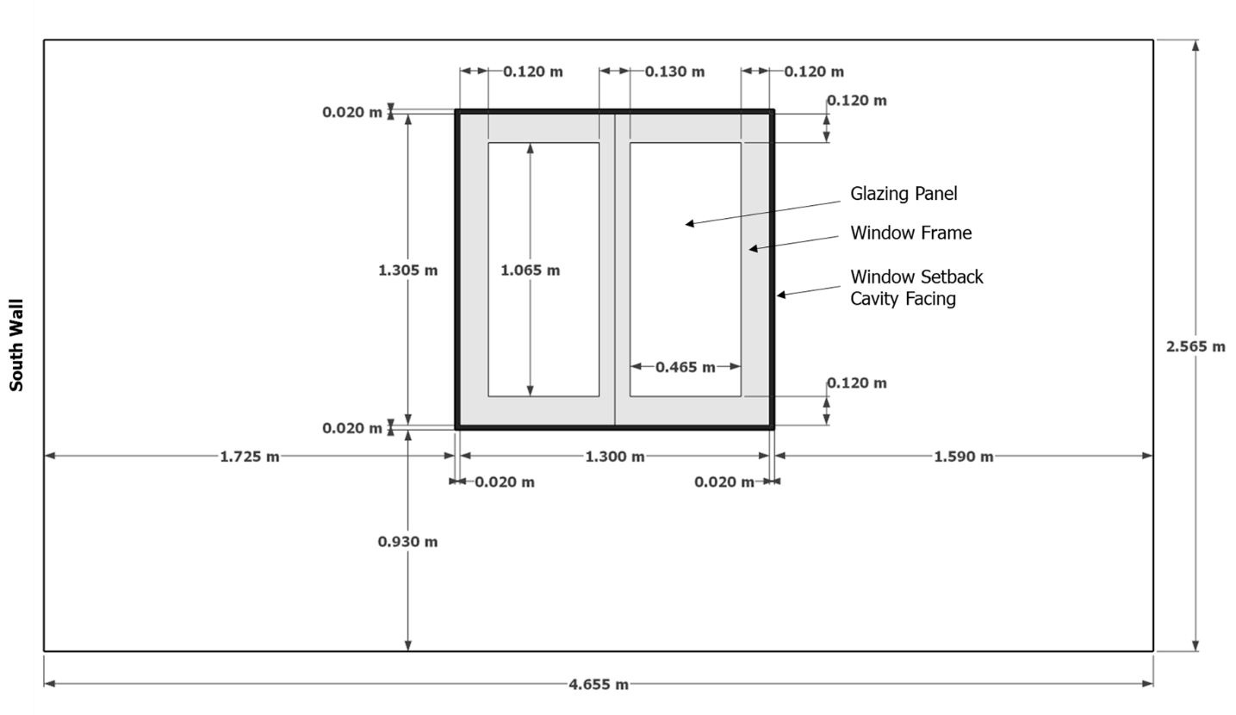

Figure 4 Dimensions of the East window, elevation view from outside test cell – Original Construction

Note: West window (Cell B) is same geometry, also located 1.725m from corner adjoining South wall

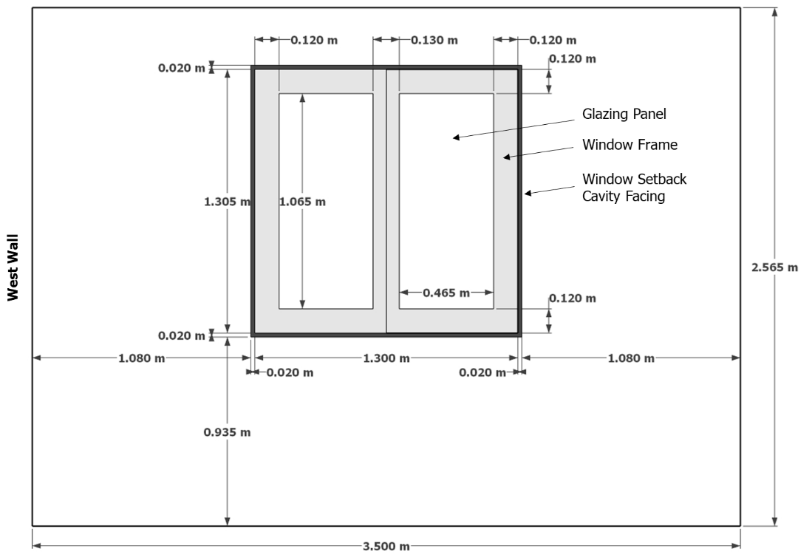

Figure 5 Dimensions of the south wall with window, elevation view from outside test cell – Original Construction

Note: South window geometry is same for Cell A and Cell B.

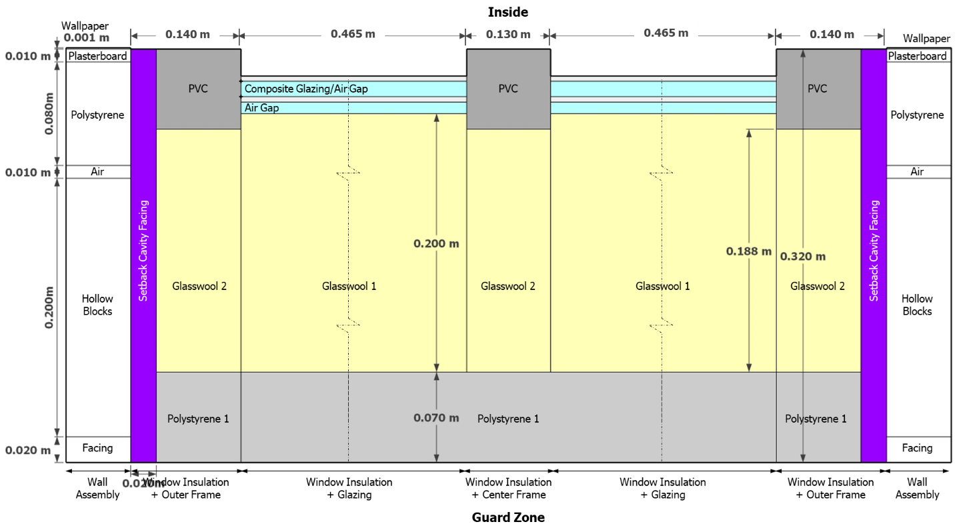

Figure 6 Window Vertical Section (partial window and frame assembly), through the window and external setback cavity looking downward (or upward) – Original Construction

Note: Window insulation geometry is same for all windows in both Cell A and Cell B.

Table 12 Characteristics of insulated windows – Original Construction

|  |  |  |  |  |
| --- | --- | --- | --- | --- |
| Material | d  Thickness  [m] | k  Conductivity  [W/mK] | ρ  Density  [kg/m3] | Cp  Specific heat  [J/kgK] |
| Window Glazing: Glass | 0.004 | 1.15 | 2700 | 750 |
| Window Glazing: Air Gap | 0.012 | 0.078 | 1.2 | 1000 |
| Window Glazing: Glass | 0.004 | 1.15 | 2700 | 750 |
| Air Gap | 0.009 | 0.062 | 1.2 | 1000 |
| Glasswool 1 | 0.2 | 0.033 | 11 | 800 |
| Glasswool 2 | 0.188 | 0.033 | 11 | 800 |
| Polystyrene 1 | 0.07 | 0.033 | 16 | 1200 |
| Setback Cavity Facing | 0.310 | 1.15 | 1950 | 850 |
| Plasterboard | 0.010 | 0.35 | 850 | 800 |

*C.5.4.2 Simplified Construction and Equivalent Material Properties*

Table 13 Blended Layer Property: “Blended Glass/Air Gap/Glass”

|  |  |  |  |  |  |  |
| --- | --- | --- | --- | --- | --- | --- |
| **Window Blended Layer** | Area  [m2] | Thickness  [m] | Volume  [m3] | Conductivity  [W/mK] | Density  [kg/m3] | Specific Heat  [J/kgK] |
| Glass | 0.990 | 0.004 | 0.004 | 1.150 | 2700 | 750 |
| Air Gap | 0.990 | 0.012 | 0.012 | 0.078 | 1.2 | 1000 |
| Glass | 0.990 | 0.004 | 0.004 | 1.150 | 2700 | 750 |
| **Blended** | **0.990** | **0.020** | **0.020** | **0.124** | **1081** | **900** |

Table 14 Blended Layer Property: “Blended PVC + Facing + Plasterboard”

|  |  |  |  |  |  |  |
| --- | --- | --- | --- | --- | --- | --- |
| **Window Blended Layer** | Area  [m2] | Thickness  [m] | Volume  [m3] | Conductivity  [W/mK] | Density  [kg/m3] | Specific Heat  [J/kgK] |
| PVC | 0.568 | 0.062 | 0.035 | 0.160 | 1380 | 1000 |
| Facing | 0.106 | 0.052 | 0.006 | 1.150 | 1950 | 850 |
| Plasterboard | 0.106 | 0.010 | 0.001 | 0.350 | 850 | 800 |
| **Blended** | **0.673** | **0.062** | **0.042** | **0.267** | **1442** | **975** |

Table 15 Blended Layer Property: “Glasswool 3”

|  |  |  |  |  |  |  |
| --- | --- | --- | --- | --- | --- | --- |
| **Window Blended Layer** | Area  [m2] | Thickness  [m] | Volume  [m3] | Conductivity  [W/mK] | Density  [kg/m3] | Specific Heat  [J/kgK] |
| Glasswool 2 | 0.568 | 0.188 | 0.107 | 0.033 | 11 | 800 |
| Facing | 0.106 | 0.188 | 0.020 | 1.150 | 1950 | 850 |
| **Blended** | **0.673** | **0.188** | **0.127** | **0.208** | **316** | **808** |

Table 16 Blended Layer Property: “Polystyrene 2”

|  |  |  |  |  |  |  |
| --- | --- | --- | --- | --- | --- | --- |
| **Window Blended Layer** | Area  [m2] | Thickness  [m] | Volume  [m3] | Conductivity  [W/mK] | Density  [kg/m3] | Specific Heat  [J/kgK] |
| Polystyrene 1 | 0.568 | 0.070 | 0.040 | 0.033 | 16 | 1200 |
| Facing | 0.106 | 0.070 | 0.007 | 1.150 | 1950 | 850 |
| **Blended** | **0.673** | **0.070** | **0.047** | **0.208** | **320** | **1145** |

### **Table C-1** UA Data Summary (Cell A)



### **Table C-2** UA Data Summary (Cell B)



### **Table C-3** UA Data Detailed Results Summary (Cell A)



**

* UAwinins is effective reduction of UA attributed to adding window insulation for each window, going from ET100 to ET110; i.e., UAwinins = (BLC,ET100 – BLC,ET110)/2.

** The “ET110 Measured” UA values shown for each wall are adjusted (reduced by ratio of measured BLC to sum of individual wall UA values) so that they sum to the measured BLCs for ET110A; see Table C-1 “UAmeas” for “BLC uninsulated window” and “BLC sum”.

### **Table C-4** UA Data Detailed Results Summary (Cell B)



**

* UAwinins is effective reduction of UA attributed to adding window insulation for each window, going from ET100 to ET110; i.e., UAwinins = (BLC,ET100 – BLC,ET110)/2.

** The “ET110 Measured” UA values shown for each wall are adjusted (reduced by ratio of measured BLC to sum of individual wall UA values) so that they sum to the measured BLCs for ET110B; see Table C-2 “UAmeas” for “BLC uninsulated window” and “BLC sum”.

**Table C-5** Imputation of Selected Material Conductivities (Cell A)





**Table C-6** Imputation of Selected Material Conductivities (Cell B)





**C.6 References for Appendix C**

ANSI/ASHRAE. (2020). ANSI/ASHRAE Standard 140-2020. *Standard Method of Test for the Evaluation of Building Energy Analysis Computer Programs*. Atlanta, Georgia, U.S.A.: ASHRAE.

Designing Buildings, The Construction Wiki. Specific Heat Capacity. <https://www.designingbuildings.co.uk/wiki/Specific_heat_capacity>

Duffie, J.A., and W.A. Beckman. (1974). *Solar Energy Thermal Processes.* New York: John Wiley & Sons.

Li F, Chen G, Zhang Y, Hao Y, Si Z. Fundamental Properties and Thermal Transferability of Masonry Built by Autoclaved Aerated Concrete Self-Insulation Blocks. Materials (Basel). 2020 Apr 3;13(7):1680. doi: 10.3390/ma13071680. PMID: 32260236; PMCID: PMC7178685.

Neymark, J., Girault, P., Guyon, G., Judkoff, R., LeBerre, R., Ojalvo, J., & Reimer, P. (2005). The “ETNA BESTEST” empirical validation data set. Proceedings of Building Simulation 2005, 15-18.

U.S. Department of Energy. (2022). EnergyPlusTM Version 22.1.0 Documentation Engineering Reference.

Walton, G. (1983). Thermal Analysis Research Program (TARP) Reference Manual. U.S. Department of Commerce, National Bureau of Standards, National Engineering Laboratory, Building Physics Division, Washington, D.C., March 1983.

Yazdanian, M., J. Klems. (1994). “Measurement of the Exterior Convective Film Coefficient for Windows in Low-Rise Buildings.”*ASHRAE Transactions 100(1) 1994.* Atlanta, Georgia, US: American Society of Heating, Refrigerating, and Air-Conditioning Engineers, Inc. Also published as LBL-34717. Berkeley, California. Lawrence Berkeley National Laboratory